How to fill out the survey form.
Following a few notes to help you fill out and submit the form. If you can do this it will help me immensely as this process will enable me to automatically capture the results in a spreadsheet and save a lot of manual work.

The Survey is a distributed PDF which you can fill out on your computer and submit via your normal email. It will require you to have the acrobat PDF reader probably
Adobe Acrobat Reader DC
It can be found at this link
https://get.adobe.com/uk/reader/
Note below is the download screen and note the middle segment where it specifies Optional offers, the two check boxes i.e. the small grey squares will be ticked by default so unless you want these please untick them. It is not a problem if you don’t, but you will have additional safe software loaded. One being an anti-virus checker and you may already have one.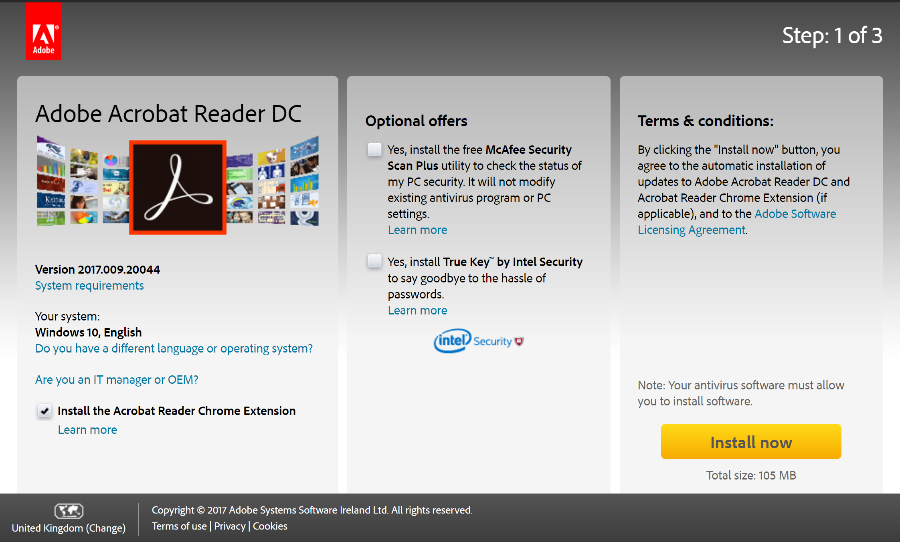
Adobe Acrobat Reader DC is the standard reader for PDF files, Adobe own the file extension. You may find that your browser will open the software but not in the right way. If you do not have the right software you may have to save and print the file by hand and then you will have to scan it to send – so it is also helpful for you to use the correct software.

One the software is downloaded – you will open the file.
If you find the file on the Clan Home website – you must down load it and then open it for editing.
if you read the file by email you may be able to edit it without an explicit down load step.
You must enter a person name in the name field, and the number coming which will except zero and other numbers. The rest are option check boxes and you just tick the ones you are interested in.
On the second page you will find two text boxes , one to add any comments you have and the other to express any food constraints that you have.

Please contact me if you have any problems or issues

Peter Clareburt
membership@clan-home.org

